Solution_Problem 6
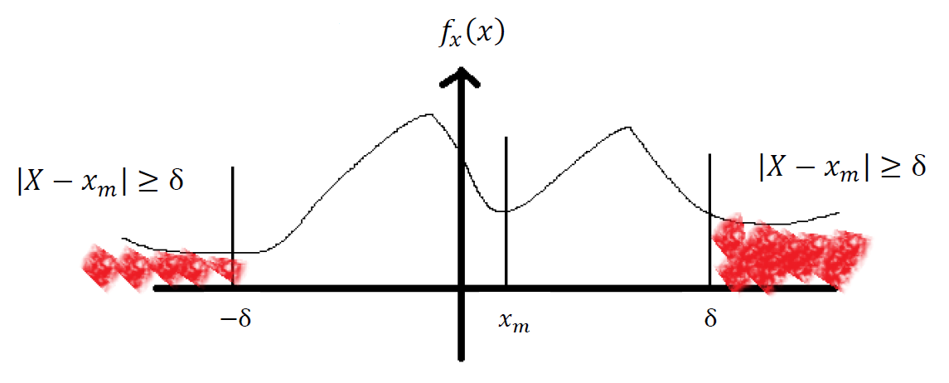
Chebyshev’s inequality:
$$P\left(\left|X-x_{m}\right|≥δ\right)≤\frac{σ_{x}^{2}}{δ^{2}}$$
$$σ_{x}^{2}=\int_{-∞}^{∞}{{\left(X-x_{m}\right)}^{2}f_{x}\left(x\right)dx}$$
$$≥\int_{\left|X-x_{m}\right|≥δ}{{\left(X-x_{m}\right)}^{2}f_{x}\left(x\right)dx}$$
$$≥\int_{\left|X-x_{m}\right|≥δ}{δ^{2}f_{x}\left(x\right)dx}$$
$$≥δ^{2}\int_{\left|X-x_{m}\right|≥δ}{f_{x}\left(x\right)dx}$$
$${⇒σ}_{x}^{2}≥δ^{2}P(\left|X-x_{m}\right|≥δ)$$
$⇒P\left(\left|X-x_{m}\right|≥δ\right)≤\frac{σ_{x}^{2}}{δ^{2}}$ 得證

