**Problem 1:(3.6)**

Consider a *square-law* detector, using a nonlinear device whose transfer characteristic is defined by  where  and  are constants,  is input, and  is the output. The input consists of the AM wave .

1. Evaluate the output .
2. Find the conditions for which the message signal  may be recovered from.

**Problem 2:(3.7)**

The AM signal  is applied to the system shown in Figure P3.7. Assuming that  for all  and the message signal  is limited to the interval , and that the carrier frequency , show that  can be obtained from the square-rooter output .

Fig. P3.7.

**Problem 3:(3.8)**

Consider a message signal  with the spectrum shown in Figure P3.8. The message bandwidth W = 1 kHz. This signal is applied to a product modulator, together with a carrier wave , producing the DSB-SC modulated signal . The modulated signal is next applied to a coherent detector. Assuming perfect synchronism between the carrier waves in the modulator and detector, determine the spectrum of the detector output when:

1. The carrier frequency kHz;
2. The carrier frequency kHz.

What is the lowest carrier frequency for which each component of the modulated signal  is uniquely determined by ?

Fig. P3.8.

**Problem 4:(3.9)**

Figure P3.9 shows the circuit diagram of a ***balance modulator.***The input applied to the top AM modulator is , whereas that applied to the lower AM modulator is ; these two modulators have the same amplitude sensitivity. Show that the output  of the balanced modulator consists of a DSB-SC modulated signal.

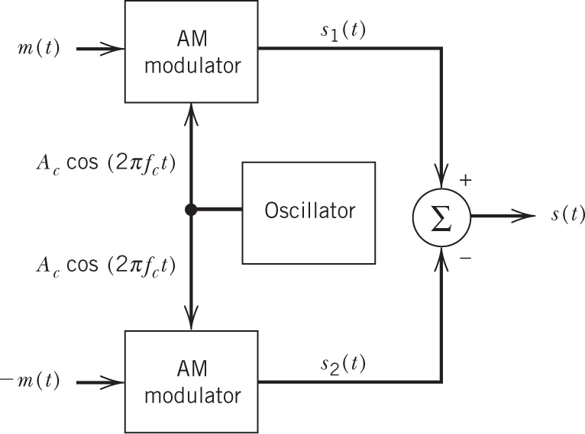

Fig. P3.9.

**Problem 5:(3.11)**

A DSB-SC modulated signal is demodulated by applying it to a coherent detector.

1. Evaluate the effect of a frequency error  in the local carrier frequency of the detector, measured with respect to the carrier frequency of the incoming DSB-SC signal.
2. For the case of a sinusoidal modulating wave, show that because of this frequency error, the demodulated signal exhibits ***beats*** at the error frequency. Illustrate your answer with a sketch of this demodulated signal.

**Problem 8:(3.20)**

(a) Consider a message signal  containing frequency components at 100, 200, and 400 Hz. This signal is applied to an SSB modulator together with a carrier at 100 kHz, with only the upper sideband retained. In the coherent detector used to recover , the local oscillator supplies a sine wave of frequency 100.02 kHz. Determine the frequency components of the detector output.

(b) Repeat your analysis, assuming that only the lower sideband is transmitted.