**Digital Communication**

**2018**–Ch6 exercises

**Problem 1**

A channel is said to be *distortionless* if the response  to an input  is , where  and  are constants. Show that if the frequency response of the channel is , where  and  are real, the necessary and sufficient conditions for distortionless transmission are  and 

**Problem 2**

Suppose a digital communication system employs Gaussian-shaped pulses of the form



To reduce the level of interference to a relatively small amount, we impose the condition that , where *T* is the symbol interval. The bandwidth  of the pulse  is defined as that value of  for which , where  is the Fourier transform of . Determine the value of  and compare this value to that of raised cosine spectrum with 100 percent rolloff.

**Problem 3**

A voice-band telephone channel passes the frequencies in the band from 300 to 3300 Hz. It is desired to design modem that transmits at a symbol rate of 2400 symbols/s, with the objective of achieving 9600bits/s. Select an appropriate QAM signal constellation, carrier frequency, and the roll-off factor of a pulse with a raise cosine spectrum that utilizes the entire frequency band. Sketch the spectrum of the transmitted signal pulse and indicate the important frequencies.

**Problem 4**

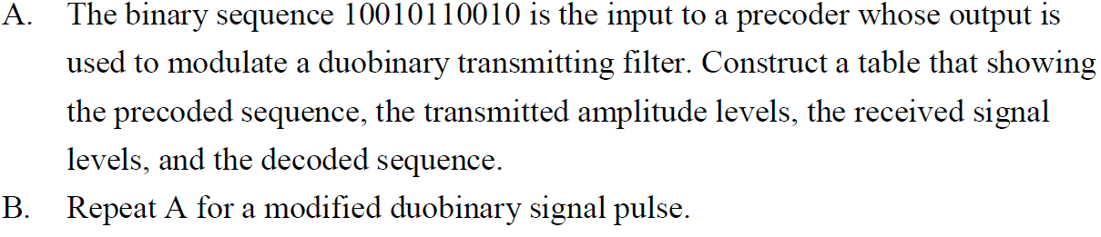

**Problem 5**

A communication system for a voice-band (3 kHz) channel is designed for a received SNR at the detector of 30 dB when the transmitter power is . Determine the value of  if it is desired to expand the bandwidth of the system to 10 kHz, while maintaining the same SNR at the detector.

**Problem 6**

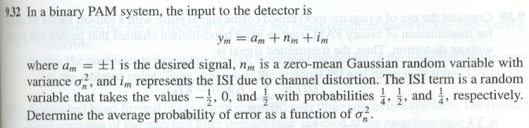

**Problem 7**

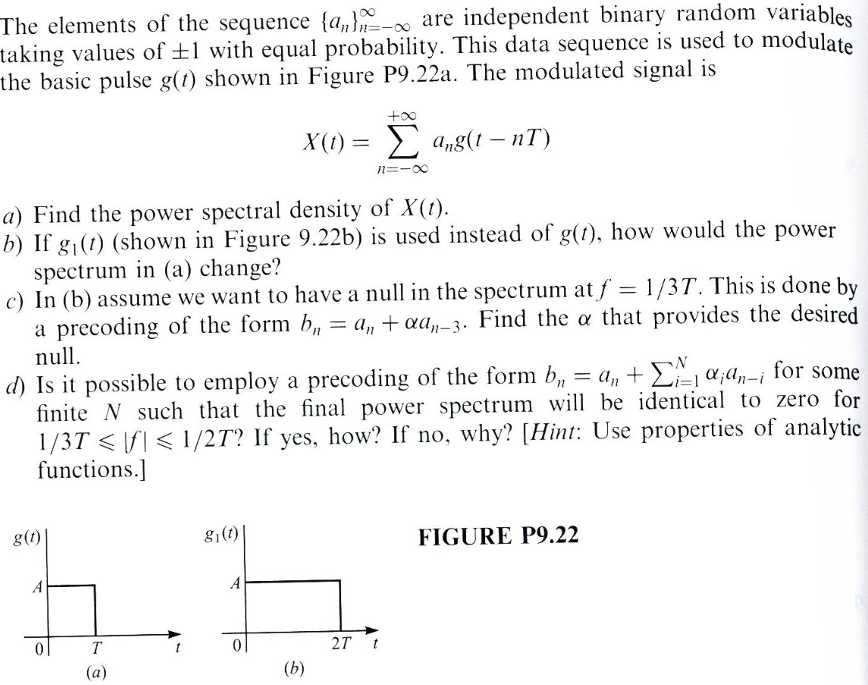

**Problem 8**

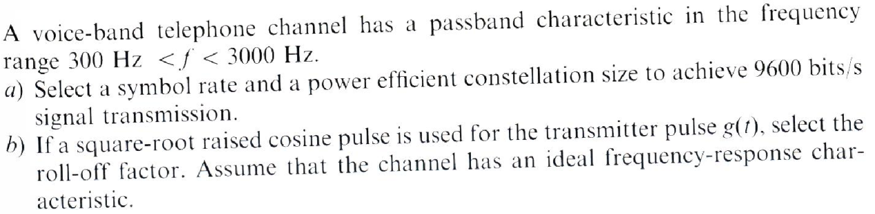

**Problem 9**

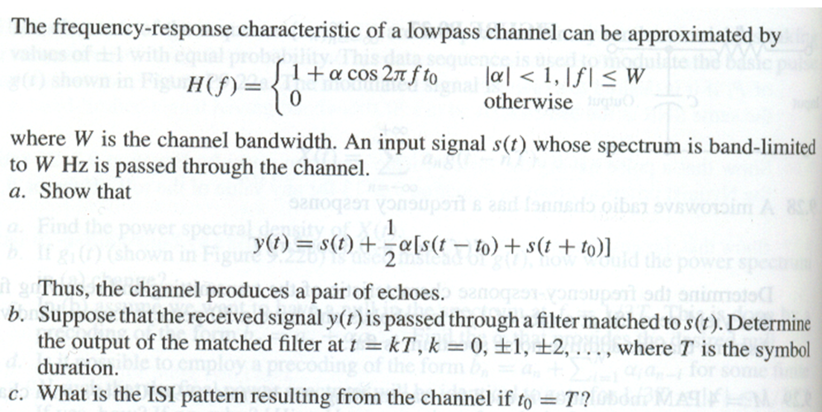

**Problem 10**

