Ch5 exercises solution

[1]

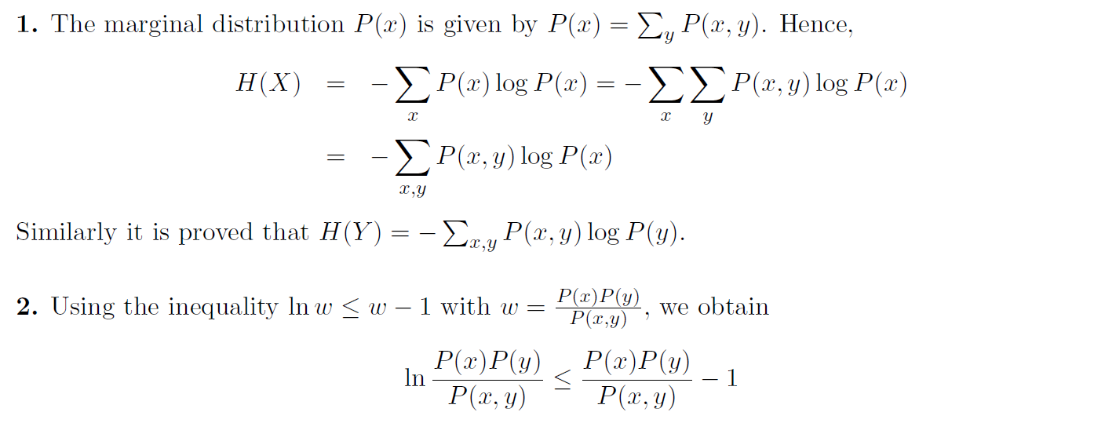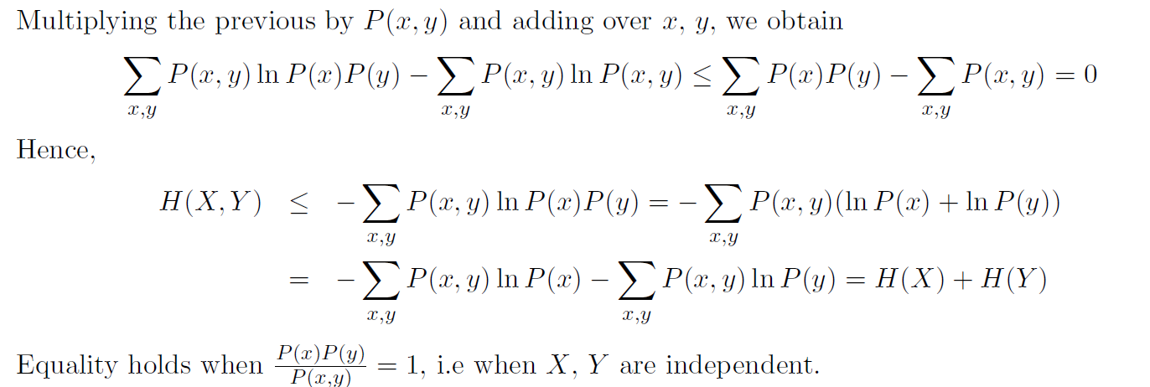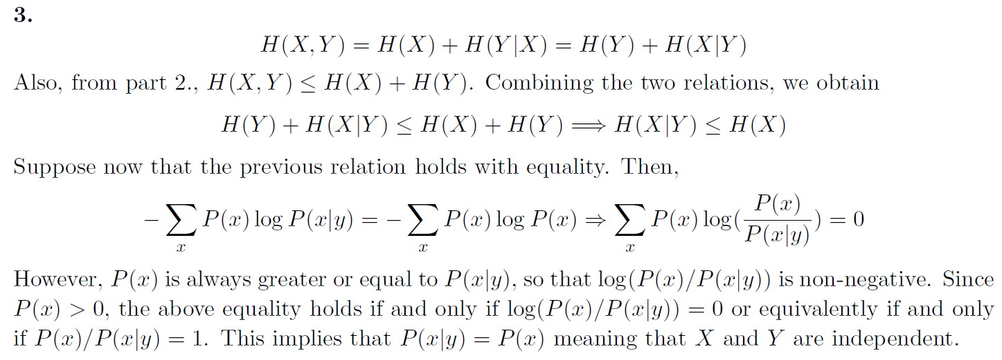

[2]

Paring the sequence by the rules of the Lempel-Ziv coding scheme we obtain the phrases 0, 00, 1, 001, 000, 0001, 10, 00010, 0000, 0010, 00000, 101, 00001, 000000, 11, 01, 0000000, 110, …

The number of the phrases is 18. For each phrase we need 5 bits plus an extra bit to represents the new source output.

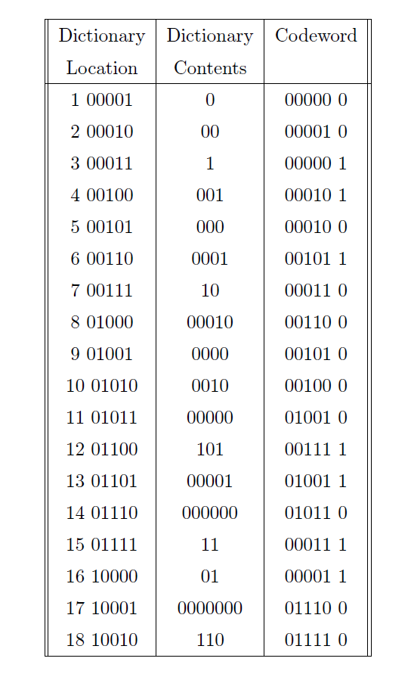

[3]

The marginal probabilities are given by



Hence,





[4]

The probability of message  is 

A Huffman code yields the codewords in the following table:

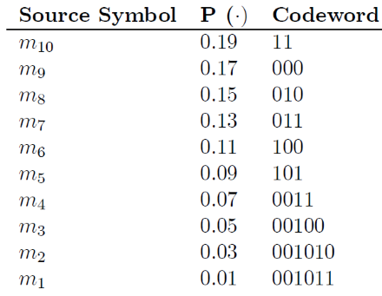

The source entropy is given by 

and the average wordlength is 

A source symbol rate of 250 symbols (samples) per second yields a binary symbol rate of 

and a source information rate of 

[5]

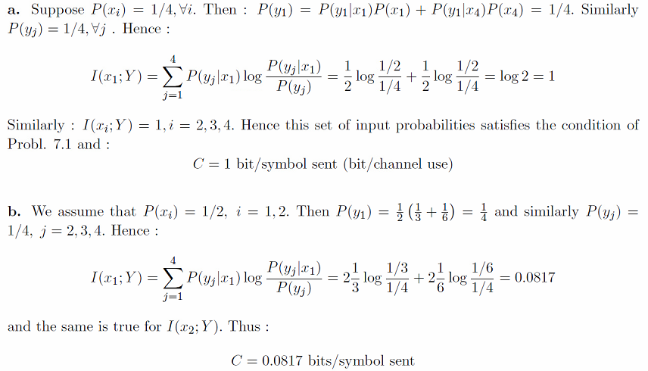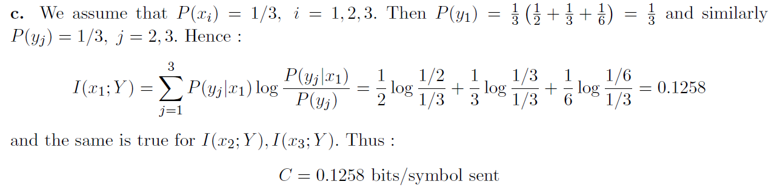

[6]

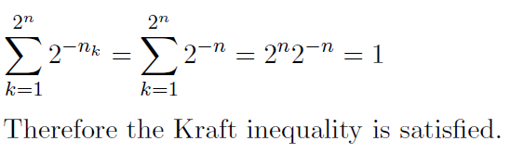

[7]

The capacity of the channel described by the transition probability matrix



is easily computed by maximizing 

The conditional entropy  can be written



where 

For the given channel 

so that  is a constant independent of . This results since each row of the matrix contains the same set of probabilities although the terms are not in the same order. For such a channel  and 

We see that capacity is achieved when each channel output occurs with equal probability. Assume that  for all . Then 

For each , 

Since  for all , , and the channel capacity is

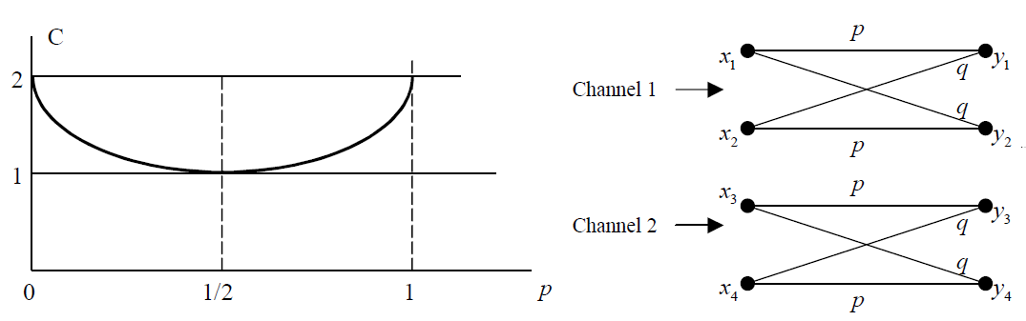 or 

[8]



the entropy at the quantizer output is



Since the symbol rate is 500 , the information rate is 

[9]

For the fourth-order extension we have

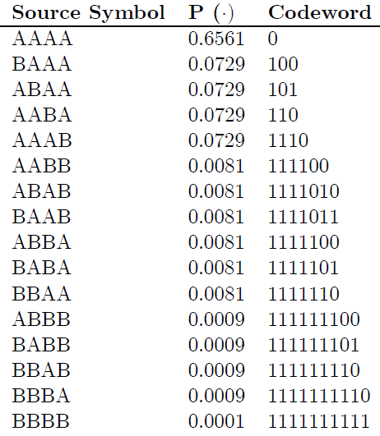

The average wordlength  which is . The efficiencies are given in the following table:

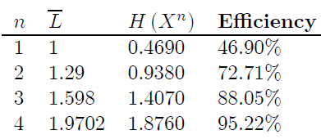

[10]

(a)



But, *X* and *G* are independent, so: , 



(b)



Since Y is the sum of two independent, zero-mean Gaussian r.v’s, it is also a zero-mean Gaussian r.v. with variance: . Hence: . Also, since :

Hence:

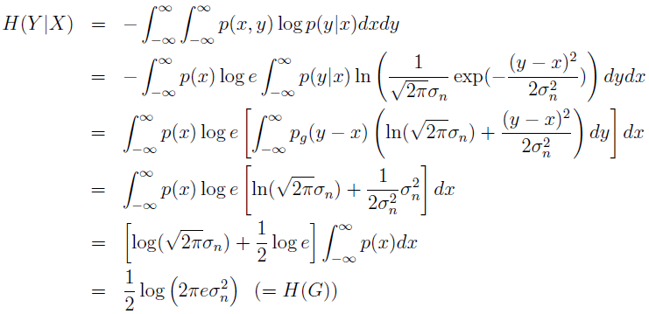

where we have used the fact that: , . From  and :

