**Digital Communication**

**2018**–Ch5 exercises

**Problem 1**

Let *X* and *Y* denote two jointly distributed, discrete-valued random variables.

1. Show that  and 
2. Use the above result to show that  When does equality hold?
3. Show that  with equality if and only if *X* and *Y* are independent.

**Problem 2**

Find the Lempel Ziv source code for the binary source sequence

000100100000011000010000000100000010100001000000110100000001100

Recover the original sequence back from the Lempel Ziv source code. *Hint*: You require two passes of the binary sequence to decide on the size of the dictionary.

**Problem 3**

Two binary random variables *X* and *Y* are distributed according to the joint distributions .

Compute , , , , and .

**Problem 4**

An analog source has an output described by the probability density function



The output of the source is quantized into 10 messages using the 9 quantizing levels



The resulting messages are encoded using a binary Huffman code. Assuming that 250 samples of the source are transmitted each second, determine the resulting binary symbol rate in symbols per second. Also determine the information rate in bits per second.

**Problem 5**

Determine the capacities of the channels shown below.

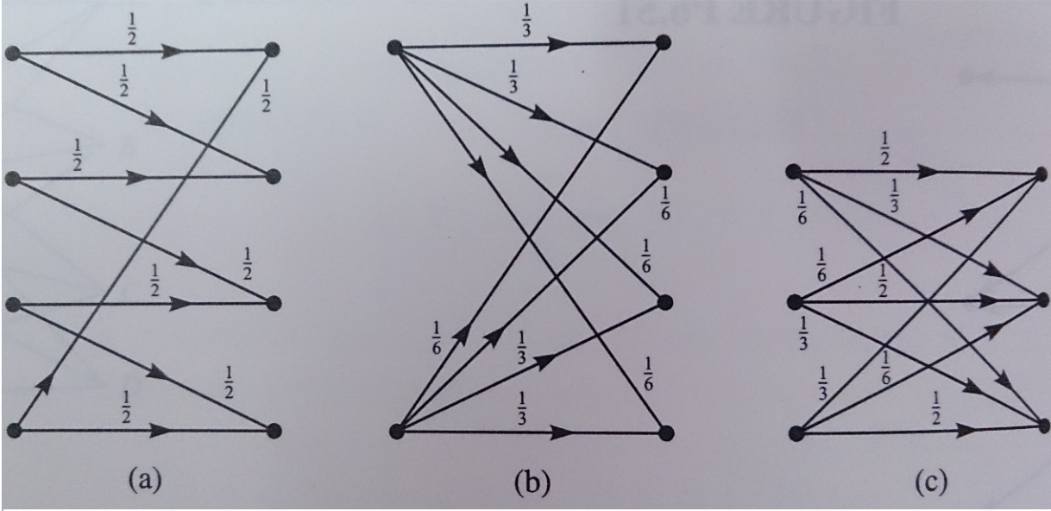

**Problem 6**

Consider a binary block code with  codewords of the same length n. Show that the Kraft inequality is satisfied for such a code.

**Problem 7**

Determine the capacity of the channel described by the channel matrix shown below. Sketch your result as a function of *p* and give an intuitive argument that supports your sketch. (Note:*q*=1-*p*)



**Problem 8**

A signal has a Gaussian amplitude-density function with zero mean and variance . The signal is sampled at 500 samples per second. The samples are quantized according to the following table. Determine the entropy at the quantizer output and the information rate in samples per second.

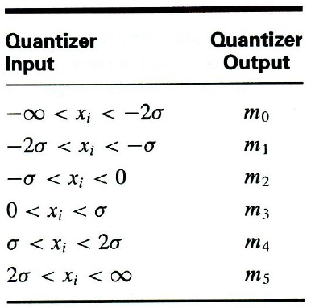

**Problem 9**

Calculate the entropy of the fourth-order extension of the source defined in Table 10.1. Determine the efficiency of the resulting codes for .

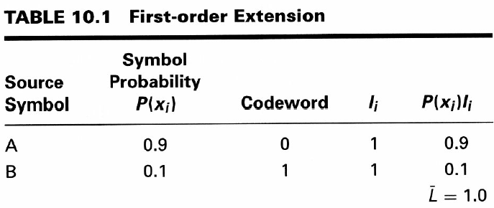

**Problem 10**

An additive white Gaussian noise channel has the output , where  is the channel input and  is the noise with probability density function



If  is a white Gaussian input with  and , determine

(a) The conditional differential entropy .

(b) The average mutual information .