**Problem 1:(4.1)**

Sketch the PM and FM waves produced by the sawtooth wave shown in Figure P4.1.

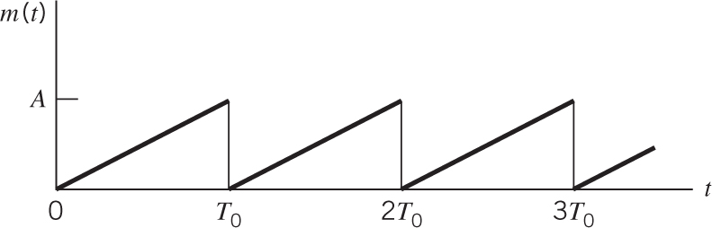

Fig. P4.1.

**Problem 2:(4.5)**

The sinusoidal modulating wave  is applied to a phase modulator with phase sensitivity . The unmodulated carrier wave has frequency  and amplitude .

1. Determine the spectrum of the resulting phase-modulated signal, assuming that the maximum phase deviation  does not exceed 0.3 radians.
2. Construct a phasor diagram for this modulated signal, and compare it with that of the corresponding narrow-band FM signal.

**Problem 3:(4.7)**

In section 4.3, we showed how the output of a narrowband modulator may be approximated when the input is a tone of frequency . Using a similar approach, derive an approximation to the output of a phase modulator with input , under the condition that max radians and . What is the approximate spectrum of this phase-modulated signal?