**Digital Communication**

**2018**–Ch4 exercises

**Problem 1**

A ternary communication system transmits one of three equiprobable signals , 0, or  every  seconds. The received signals is ,  or , where  is white Gaussian noise with  and . The optimum receiver computes the correlation metric



and compare  with a threshold  and a threshold . If , the decision is made that was sent. If , the decision is made in favor of . If , the decision is made in favor of .

1. Determined the three conditional probabilities of error:  given that  was sent,  given that  was sent, and  given that  was sent.
2. Determined the average probability of error  as a function of the threshold , assuming that the three symbols are equally probable a priori.
3. Determine the value of  that minimizes .

**Problem 2**

A matched filter has the frequency response 

1. Determine the impulse response  corresponding to .
2. Determine the signal waveform to which the filter characteristic is matched.

**Problem 3**

The two equivalent low-pass signals show in Figure P5.8 are used to transmit a binary sequence over an additive white Gaussian noise channel. The received signal can be expressed as



where  is a zero-mean Gaussian noise process with autocorrelation function



1. Determine the transmitted energy in  and  and the cross-correlation coefficient .
2. Suppose the receiver is implemented by means of coherent detection using two matched to  and the other to .Sketch the equivalent low-pass impulse responses of the matched filter.

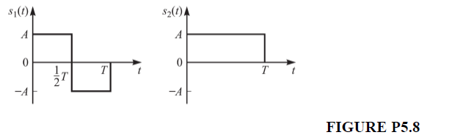

**Problem 4**

The possible transmitted signals are either  or  for  seconds.

Let the threshold be set at . Please derive the probabilities of error in Q-function, including  been transmitted,  been transmitted, and the average probability of error. Express your result in terms of signal energy averaged over both signal possibilities, which are assumed equally probable; that is



**Problem 5**

Three equiprobable messages , and  are to be transmitted over an AWGN channel with noise power spectral density . The messages are



1. What is the dimensionality of the signal space?

2. Find an appropriate basis for the signal space.

3. Draw the signal constellation for this problem.

4. Derive and sketch the optimal decision regions and .

5. Which of the three messages is most vulnerable to errors and why? In other words, which of is largest?

**Problem 6**

The two equivalent low-pass signals shown in Figure P5.11 are used to transmit a binary information sequence. The transmitted signals, which are equally probable, are corrupted by additive zero-mean white Gaussian noise having an equivalent low-pass representation $z(t)$ with an autocorrelation function



1. What is the transmitted signal energy?
2. What is the probability of a binary digit error if coherent detection is employed at the receiver?
3. What is the probability of a binary digit error if noncoherent detection is employed at the receiver?

