1.

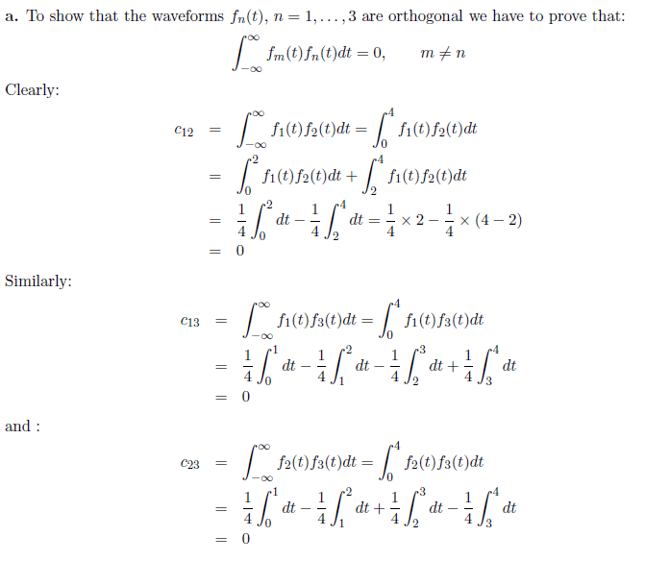

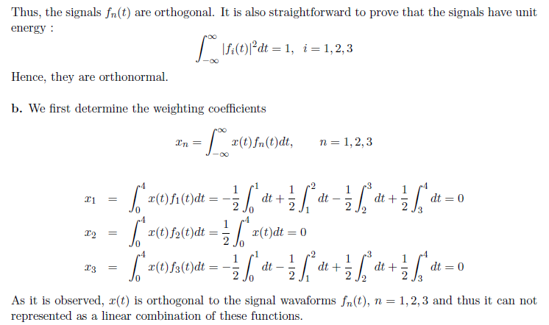

2.

a) Consider the QAM constellation of figure. Using the Pythagorean theorem we can find the radius of the inner circle as:



Since  is the third side of a triangle with  and  the two other sides and angle between then equal to , we obtain:



b) If we denote by *r* the radius of the circle, then using the cosine theorem we obtain:



3.

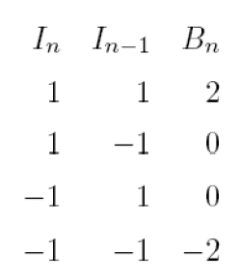a) . Hence:

The signal space representation is given in the following figure, with 

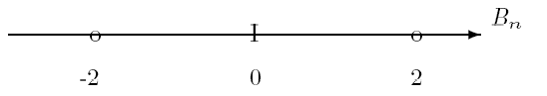

b)





Since the sequence {} consists of independent symbols:



Hence:







4.

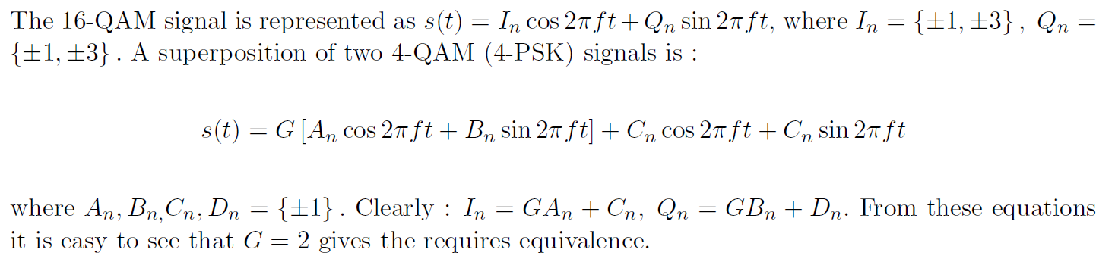

5.

a) , with the sequence {} being uncorrelated random variables(i.e )

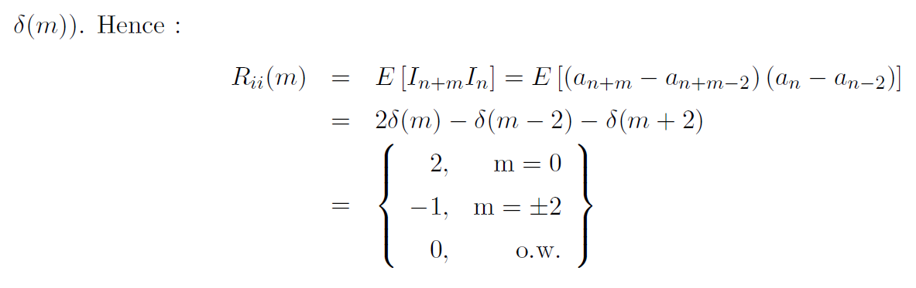

b)

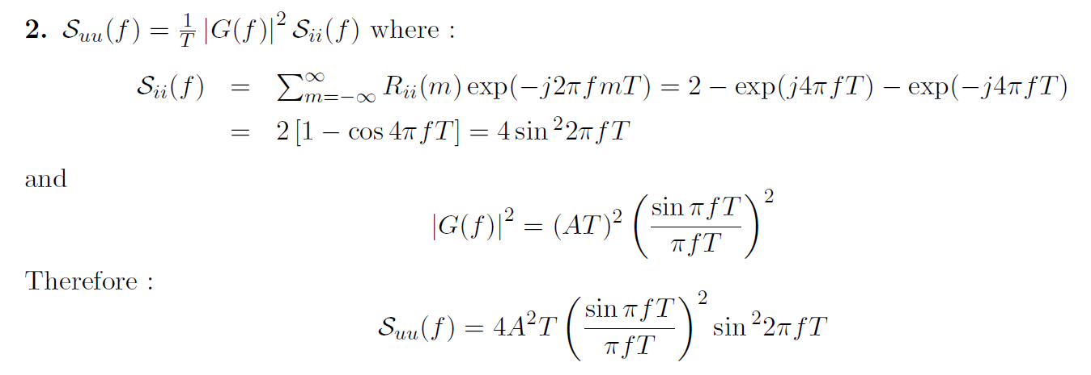

c)

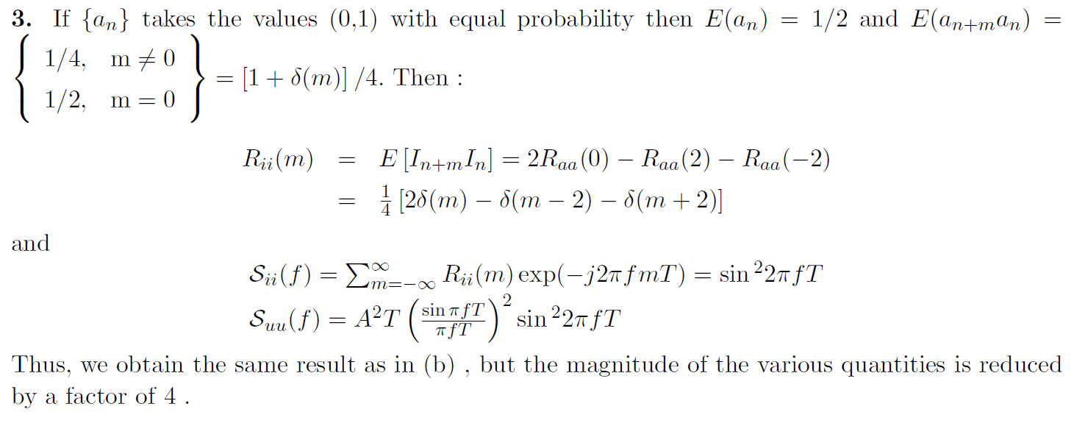

6.

a) 



b) 



c) 



, , 









d) …(1)



…(2)

由(1)(2)可得  is WSS







 is lowpass r.p.

7.

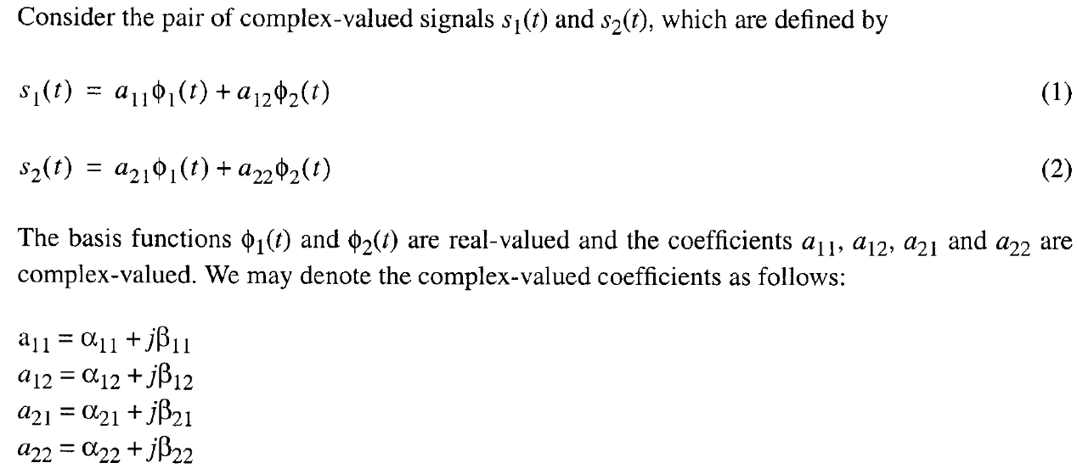

On this basis, we may represent the signals  and  by the following respective pair of vectors：

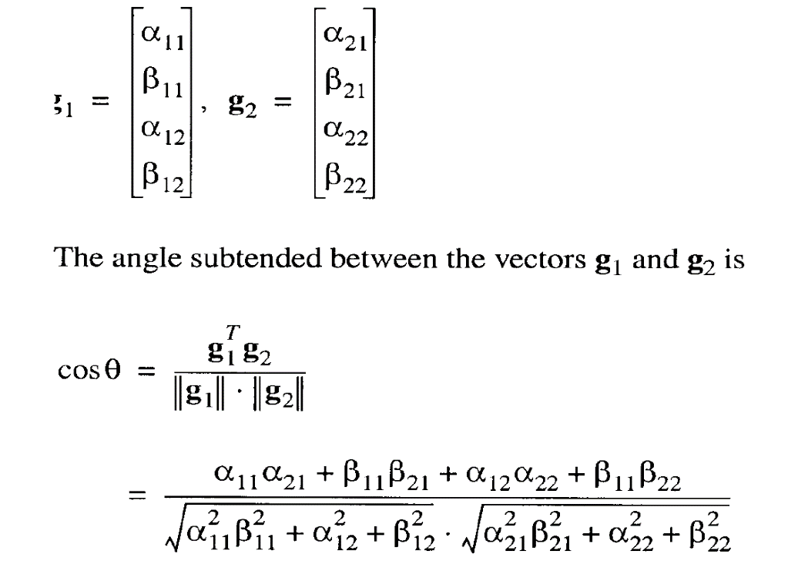

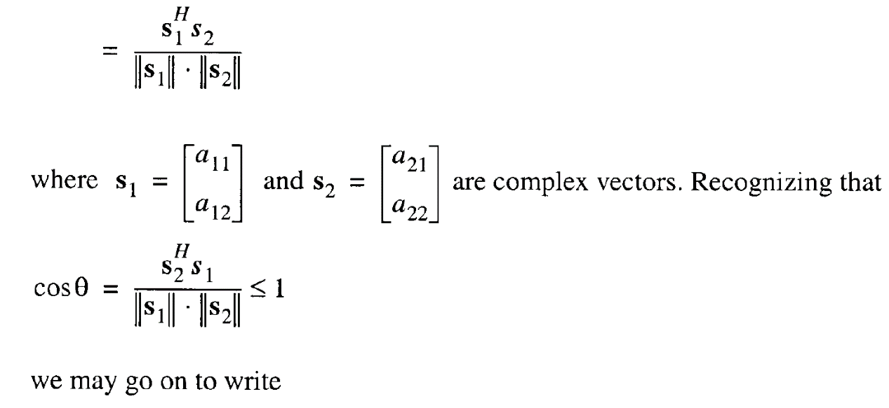

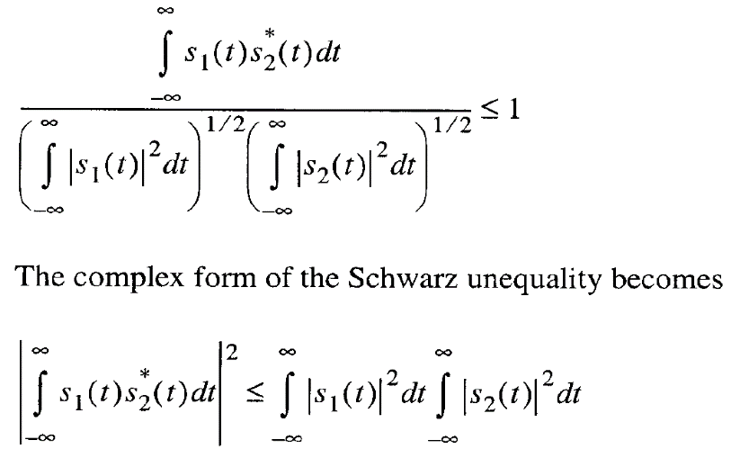

The equality holds when  and  are co-linear, that is,  where *k* is any real-valued constant.