**Digital Communication**

**2018**–Ch3 exercises

**Problem 1**

Consider the three waveforms $f_{n}\left(t\right)$ shown in the following figure.

1. Show that these waveforms are orthonormal. 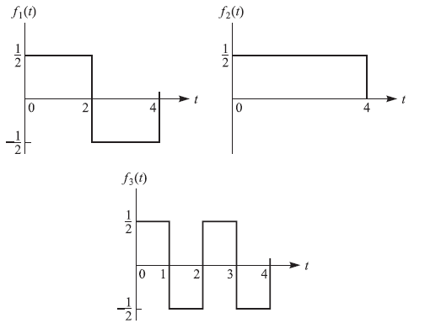
2. Express the waveform $x\left(t\right)$ as a linear combination of $f_{n}\left(t\right), n=1,2,3$, if

$$x\left(t\right)=\left\{\begin{aligned}-1 , 0≤t<1 \\ 1, 1≤t<3 \\ -1, 3≤t<4\end{aligned}\right.$$

and determine the weighting coefficients.

**Problem 2**

Consider the octal signal point constellations in the following figure.

1. The nearest-neighbor signal points in the 8-QAM signal constellation are separated in distance by A units. Determine the radius *a* and *b* of the inner and outer circles, respectively.
2. The adjacent signal points in the 8-PSK are separated by a distance of A units. Determine the radius *r* of the circle.

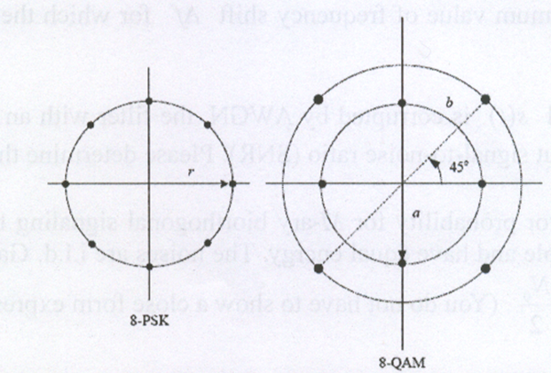

**Problem 3**

A PAM partial-response signal (PRS) is generated as shown in the following figure by exciting an ideal lowpass filter of bandwidth W by the sequence



at a rate 1/T=2W symbols/s. The sequence $\{I_{n}\}$ consists of binary digits selected indepently from the alphabet $\{1,-1\}$ with equal probability. Hence, the filtered signal has the form



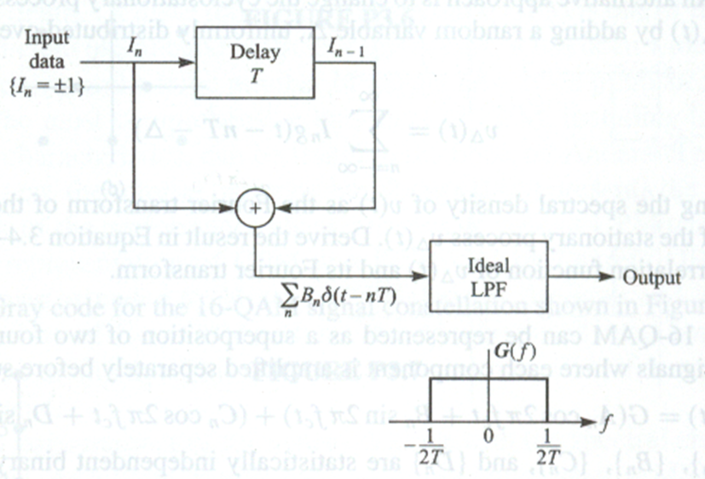

1. Determine the probability of occurrence of each symbol.
2. Determine the autocorrelation and power density spectrum of the three-level sequence $\{B_{n}\}$.

**Problem 4**

Show that 16-QAM can be represented as a superposition of two four-phase constant envelpoe signals where each component is amplified separately before summing, i.e.,



where $\left\{A_{n}\right\}, \left\{B_{n}\right\}, \left\{C_{n}\right\}, and \left\{D_{n}\right\},$ are statistically independent binary sequences with elements from the set $\{1,-1\}$ and G is the amplifier gain. Thus, show that the resulting signal is equivalent to



and determineandin terms of,,, and.

**Problem 5**

The lowpass equivalent representation of a PAM signal is



Suppose $g(t)$ is a rectangular pulse and $I_{n}=a_{n}-a_{n-2},$ where $\{a_{n}\}$ is a sequence of uncorrelated binary-valued (1,-1) random variables that occur with equal probability.

1. Determine the autocorrelation function of the sequence $\{I_{n}\}$.
2. Determine the power density spectrum of *u*(*t*).
3. Repeat (b) if the possible values of the $a_{n}$ are (0,1).

**Problem 6**

Let $X(t)$ denote a (real, zero mean, WSS) bandpass process with autocorrelation function  and power spectral density , where , and let  denote the Hilbert transform of $X(t)$. Then $\hat{X}(t)$ can be viewed as the output of a filter, with impulse response  and transfer function , whose input is $X(t)$.

Recall that when  passes through a system with transfer function  and the output is , we have and .

1. Prove that $R_{\hat{X}}\left(τ\right)=R_{X}(τ)$.
2. Prove that $R_{X\hat{X}}\left(τ\right)={-\hat{R}}_{X}(τ)$..
3. If $Z\left(t\right)=X\left(t\right)+j\hat{X}(t)$, determine $S_{Z}(f)$.
4. Define . Show that  is a lowpass WSS random process, and determine .

**Problem 7**

Consider a pair of complex-valued signals  and  that are respectively represented by



where the basis functions  and  are both real valued, but the coefficients  and  ate complex valued.

Prove the complex form of the Schwarz inequality:



where the asterisk denotes complex conjugation. When is this relation satisfied with the equality sign?