Q1.

1. Calculate if it given that 
2. Calculate P(B) if it given that

Q2.

Five fair coins are tossed ,Let x is the number of heads ,find P(X=x)=?

for x = 0,1,2,3,4,5.

Q3.

$X(t)$ is a wide sense stationary random process with average power equal to 1. Let $Θ$ denote a random variable with uniform distribution over $[0, 2π]$ such that $X(t)$ and $Θ$ are independent.

(a)What is $E\left[X^{2}\left(t\right)\right]?$

(b)What is $E\left[cos⁡(2πf_{c}t+Θ)\right]?$

(c)Let $Y\left(t\right)=X\left(t\right)cos⁡(2πf_{c}t+Θ)$. What is $E\left[Y(t)\right]?$

(d)What is the average power of $Y\left(t\right)$?

Q4.

Let *A* be a nonnegative random variable that is independent of any collection of samples $X\left(t_{1}\right),…,X\left(t_{k}\right)$ of any collection of samples process $X\left(t\right)$. Is $Y\left(t\right)=A+X\left(t\right)$ a wide sense stationary process?

Q5.

A zero-mean stationary process  is applied to a linear filter whose impulse response is defined by a truncated exponential:

  
Show that the power spectral density of the filter output *Y*(t) is defined by



where is the power spectral density of the filter input.

Q6.

The random variable is defined as



where the , =1, 2, ...,n, are statistically independent random variables with



1. Determine the characteristic function of .
2. From the characteristic function, determine the moments  and .

**Q7.**

The autocorrelation function of a stochastic process  is



Such a process is called white noise. Suppose  is the input to an ideal band-pass filter having the frequency response characteristic shown in Figure P2.12. Determine the total noise power at the output of the filter.

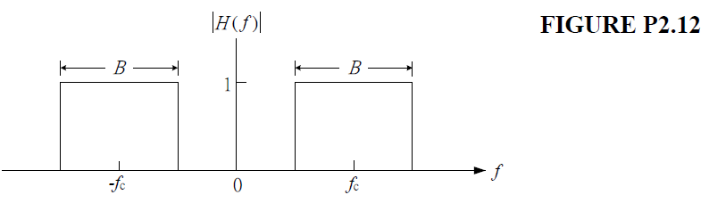

**Q8.**

One experiment has four mutually exclusive outcomes  and a second experiment has three mutually exclusive outcomes  The joint probabilities P(,) are



Determine the probabilities , and .

**Q9.**

The PDF of a Cauchy distributed random variable  is

 

1. Determine the mean and variance of .
2. Determine the characteristic function of .

**Q10.**

The central chi-square distribution’s PDF is



Determine the characteristic function of .