**Chapter10**

**Problem 1:(10.1)**

Let $p$ denote the probability of some event. Plot the amount of information gained by the occurrence of this event for $0≤p≤1$.

**Problem 2:(10.2)**

A source emits one of four possible symbols during each signaling interval. The symbols occur with the probabilities:

$$p_{0}=0.4$$

$$p_{1}=0.3$$

$$p_{2}=0.2$$

$$p_{3}=0.1$$

Find the amount of information gained by observing the source emitting each of these symbols.

**Problem 3:(10.3)**

A source emits one of four symbols  with probabilities 1/3, 1/6, 1/4, and 1/4, respectively. The successive symbols emitted by the source are statistically independent. Calculate the entropy of the source.

**Problem 4:(10.4)**

Let $X$ represent the outcome of a single roll of a fair die. What is the entropy of $X$?

**Problem 5:(10.7)**

Consider the four codes listed below:

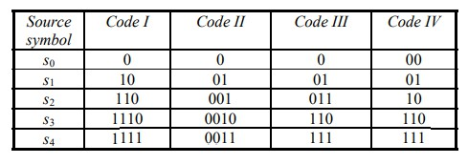

Two of these four codes are prefix codes. Identify them, ~~and construct their individual decision trees~~(講義沒有).

**Problem 6:(10.9)**

A discrete memoryless source has an alphabet of seven symbols whose probabilities of occurrence are as described here:



Compute the Huffman code for this source, moving a combined symbol as high as possible. Explain why the computed source code has an efficiency of 100 percent.