**Communication Systems**

**2018** Ch3 exercises

**Problem 1:**

Consider a square-law detector, using a nonlinear device whose transfer characteristic is defined by



Where and  are constant.  is input, and  is the output.

The input consists of the AM wave



1. Evaluate the output .
2. Find the conditions for which the message signal  may be recovered from.

**Problem 2:**

The AM signal



is applied to the system shown in Figure P3.7. Assuming that  for all and the message signal  is limited to the interval , and that the carrier frequency ,show that  can be obtained from the square-rooter output .

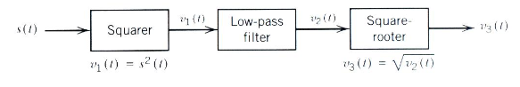

**Problem 3:**

Consider a message signal  with the spectrum shown in Figure P3.8. The message bandwidth W = 1 kHz. This signal is applied to a product modulator, together with a carrier wave , producing the DSB-SC modulated signal . The modulated signal is next applied to a coherent detector output when:

1. The carrier frequency kHz and (b) the carrier frequency kHz.

What is the lowest carrier frequency for which each component of the modulated signal  is uniquely determined by ?

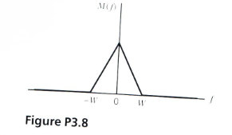

**Problem 4:**

Figure P3.9 shows the circuit diagram of a ***balance modulator.***The input applied to the top AM modulator is , whereas that applied to the lower AM modulator is -; these two modulators have the same amplitude sensitivity. Show that the output  of the balanced modulator consists of a DSB-SC modulated signal.

