**Communication Systems**

**2018** Ch3 exercises solution

**Problem 1:**

Let



1. Then the output of the square-law device is   
   
2. The desired signal, namely , is due to the  - hence, the name“square-law detection”. This component can be extracted by means of a low-pass filter. This is not the only contribution within the baseband spectrum, because the term  will give rise to a plurality of similar frequency components. The ratio of wanted signal to distortion is . To make this ratio large, the percentage modulation, that is,  should be kept small compared with unity.

**Problem 2:**

The squarer output is



The amplitude spectrum of  is therefore as follows, assuming that  is limited to the interval :

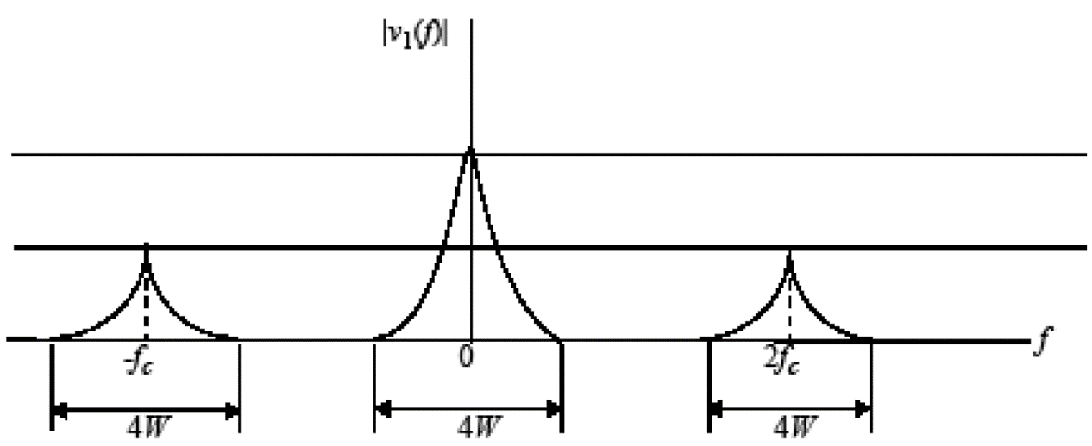

Since , we find that . Therefore, by choosing the cutoff frequency of the low-pass filter greater than , but less than , we obtain the output



Hence, the square-rooter output is



which, except for the dc component , is proportional to the message signal .

**Problem 3:**

1. For , the spectral of the message signal , the product modulator output , and the coherent detector output  are as follows, respectively:

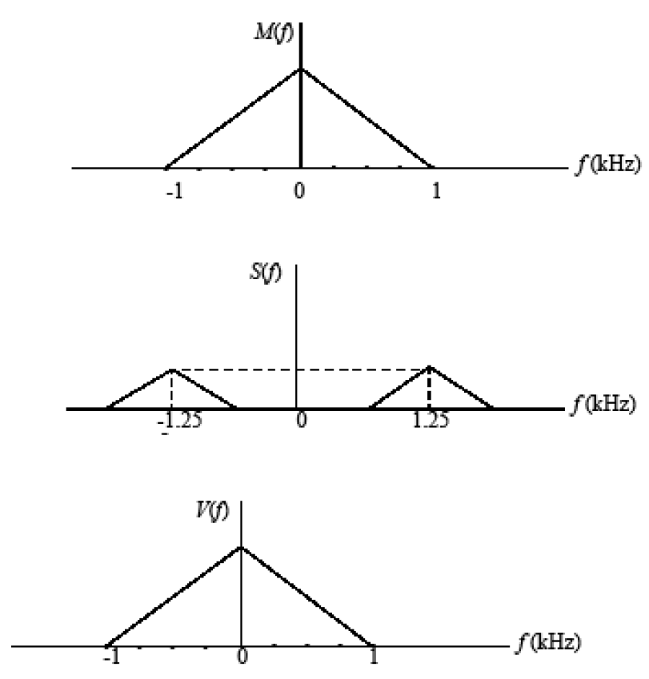

1. For the case when , the respective spectra are as follows:

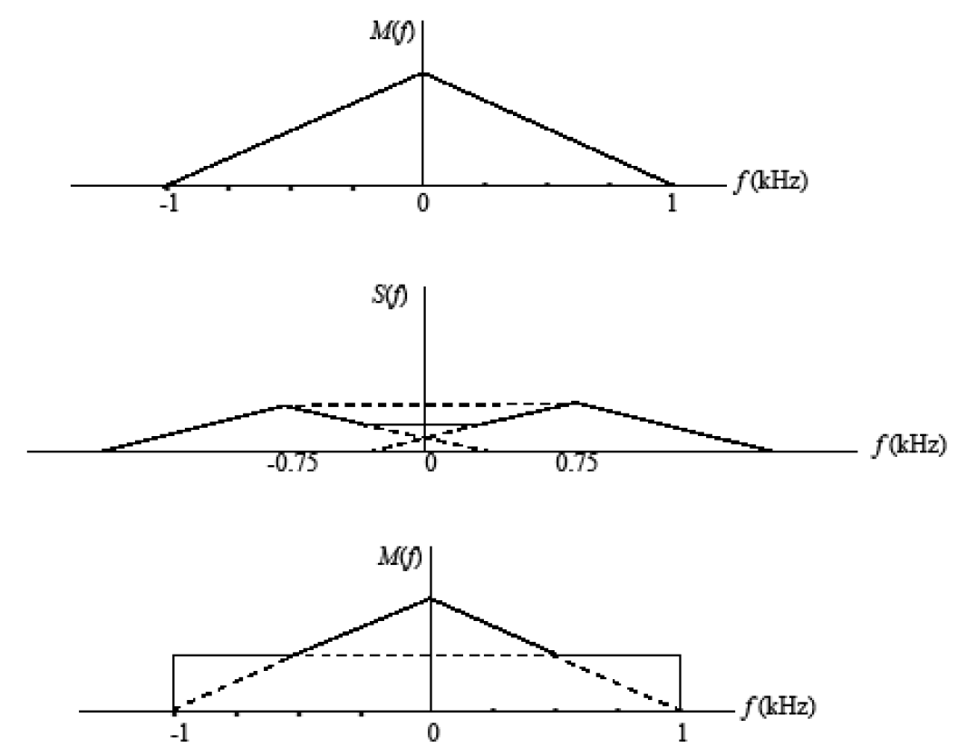

To avoid sideband-overlap, the carrier frequency  must be greater than or equal to . The lowest carrier frequency is therefore  for each sideband of the modulated wave  to be uniquely determined by .

**Problem 4:**

The two AM modulator outputs are





Subtracting  from :



which represents a DSB-SC modulated wave.