Communication Systems
2018–Ch10 exercises
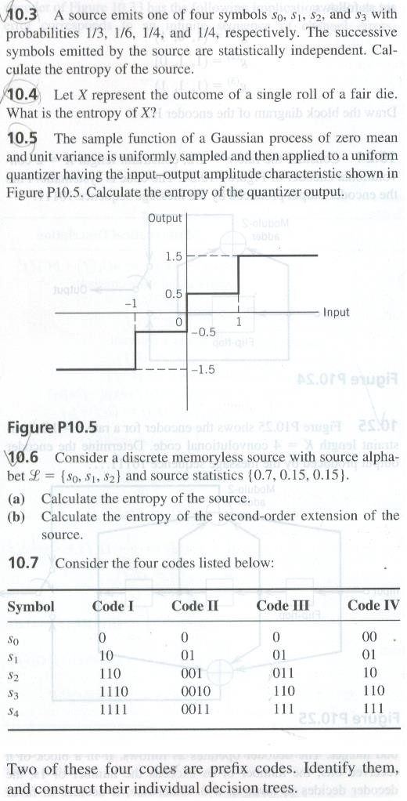
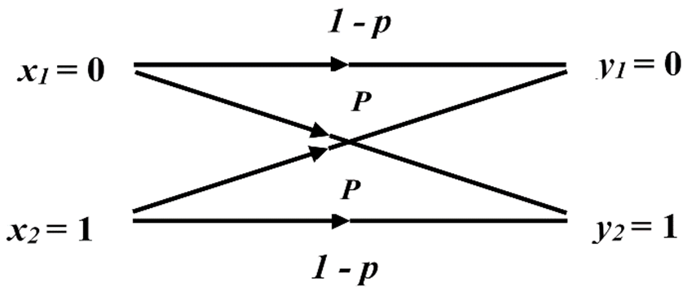
10.20 Consider the (7, 4) Hamming code, the generator matrix is
$$G=\left[\begin{aligned}1 1 0 1 0 0 0 \\ 0 1 1 0 1 0 0 \\ 1 1 1 0 0 1 0 \\ 1 0 1 0 0 0 1\end{aligned}\right]$$
Show that the generator matrix G and parity-check matrix H satisfy the condition.
$${HG}^{T}=0$$

10.21
(a) For the (7, 4) Hamming code described in Example 10.20, construct the eight codewords in the dual code.
(b) Find the minimum distance of the dual code determined in part (a).

