Communication Systems
2018–Ch10 exercises solution
Problem 10.3
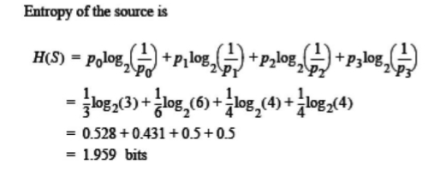

Problem 10.4
Let X denote the number showing on a single roll of a dice. With a dice having six faces, we note the $p_{X}$ is $1/6$. Hence, the entropy of X is

Problem 10.5
$$H=-2(0.1611\log_{2}{(0.1611)}+0.3389\log_{2}{(0.3389)})$$

Problem 10.7
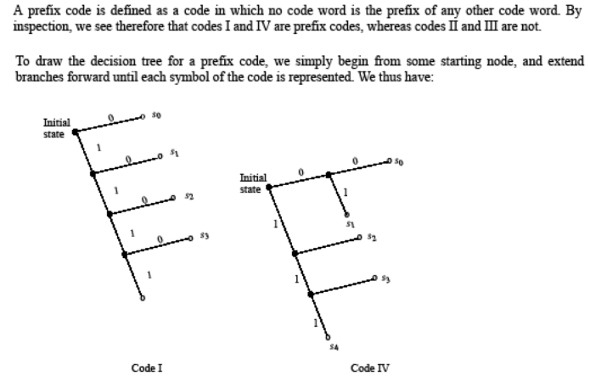

Problem 10.9

Problem 10.13
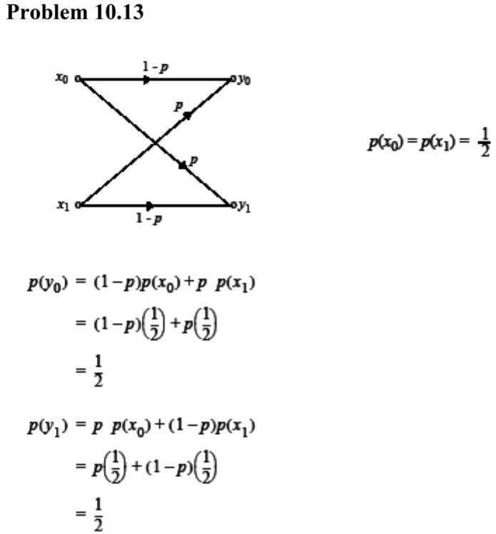
Problem 10.20
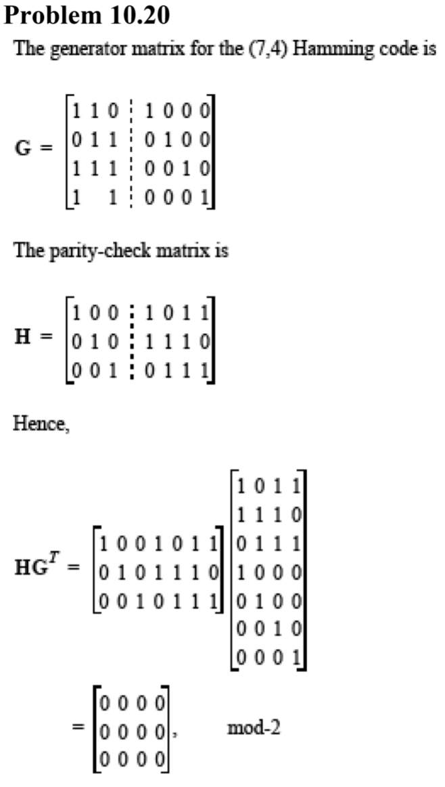
Problem 10.21
